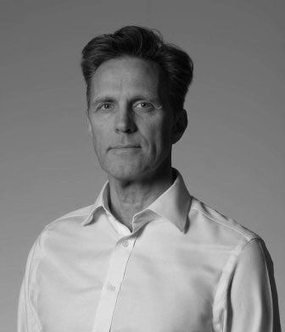
Gert Nilsson Eldrimner
CEDR Panel Admission: 2018
Languages: English, Swedish, Danish

“If Gert cannot manage it, nobody can”
- Client Feedback, 2016

Overview
Gert Nilsson Eldrimner is a commercial lawyer based in Stockholm, Sweden, since 1991. Nowadays he is also based in Copenhagen, Denmark. He has litigated a large number of commercial disputes and also been involved in arbitration, both as a party representative and arbitrator. Since his CEDR accreditation he has also more than 3,200 hours (Febr 2021) of working as a mediator.

Summary of Dispute resolution experience
Commercial/Business Law
- Continuous legal advice and litigation/arbitration: 1991 – Present
- Mediation: 2010 – Present

Contract Law
- Continuous legal advice and litigation/arbitration: 1991 – Present

Employment/Labour Law
- Continuous legal advice and litigation/arbitration: 1991 – Present
- Mediation: 2010 – Present

Construction Law
- Continuous legal advice and litigation/arbitration: 1991 – Present
- Mediation: 2010 – Present

Tort Law
- Continuous legal advice and litigation/arbitration: 1991 – Present

Family Law
- Mediation: 2013 – Present

Nonviolent Communication (NVC)
- Mediation: 2009 - Present

Dispute Resolution, Professional Appointments
- Founder and organizer of the network “Swedish Mediators” (svenska-medlare.se)
- Lecturer in mediation at courses and at the Faculty of Law at the University of Copenhagen
- Co-founder and Board Member (former Chairman) of the Swedish Institute for Mediation (sim-medling.org)
- Initiator and organizer of Mediation Seminars in the Swedish Parliament and at the Danish organization Danish Industry in Copenhagen
- Former Member of the Advisory Board of the Swedish Arbitration Centre INIRES (inires.se)
- Founder and former Chairman of the Swedish section of the European Mediation Organisation, GEMME (gemme.eu)
- Honorary Member of the Croatian Mediation Association, HUM

Professional Background
2010 – Present: Professional Mediator, Sweden and abroad
1991 – Present: Attorney-at-law, Stockholm, Sweden
1988 – 1990: Law clerk, Södertälje District Court, Sweden
1981 – 1988: Police Officer, Stockholm, Sweden

Personal Mediation Style
Gert has various kinds of mediation training; commercial, workplace, peacebuilding, nonviolent communication (NVC) and family. Therefore, he does not only follow a mediation formula, but instead focuses on what is needed in the room at the moment. He is engaged in international mediation including co-mediation in cross-border/cultural disputes and very interested in the combination of mediation / neuroscience. His mediation style is mainly facilitative and personally he is both relaxed and structured. He is persistent, patient and encouraging.

Personal Interests
Gert is very interested in culture, such as music, theatre, opera, ballet, art, traveling, wine and food. He is also the loving father of four children and a half marathon runner. He lives in Stockholm, Sweden and Copenhagen, Denmark.

