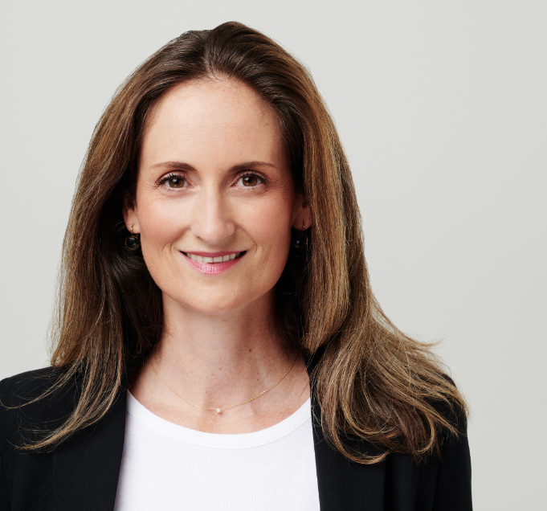
Anne-Karin Grill, FCIArb
CEDR Accreditation: 2013
CEDR Panel Admission: 2020

"Smart, constructive and a great communicator."

Overview
Anne-Karin Grill is an experienced international arbitration lawyer and well-versed in other forms of alternative dispute resolution (ADR), especially mediation. Anne-Karin advises clients in commercial arbitration proceedings in accordance with the rules of key arbitral institutions and has an excellent track-record in investor-state dispute settlement. In addition to her advocacy work before international tribunals, Anne-Karin serves as arbitrator and acts as CEDR accredited mediator in multi-jurisdictional disputes.
Who's Who Legal (2021) ranks Anne-Karin among the leading Austrian ADR practitioners and describes her as "simply brilliant and absolutely charming" and adds that clients adore her for her sound commercial judgment and persuasive advocacy. The publication also emphasizes her personal dedication in defending her clients' interests ("she always helps secure a positive result"). The Legal 500 (2020) refers to her as the "go-to mediation specialist" in Austria.
Dispute Resolution Experience
Cases successfully mediated by Anne-Karin include matters such as:
Commercial
- Sales of goods.
- Sale and purchase of private businesses.
- Sales agency.
Corporate
- Shareholder disputes.

Construction
- Construction, developers, contractors and subcontractors disputes.
- Schedule of works.
Other Experience
- Insurance.
- Wealth succession.
- Mediation processes involving international organization and sovereigns.
- Hybrid ADR proceedings (Med-Arb, Arb-Med, Arb-Med-Arb).
Professional Background
Anne-Karin has received much acclaim for her work as dispute resolution partner at a leading CEE law firm and later at a prominent Austrian entity. Since 2020, her vision of modern dispute resolution services supports her own legal advisory business.
Anne-Karin is a member of the ICC International Court of Arbitration, a member of the Board of the Austrian Arbitration Association (Arb|Aut), and she also serves on the Mediation Advisory Board of the Vienna International Arbitral Centre (VIAC). Upon the nomination of the Republic of Austria, she has been appointed to the Panel of Conciliators maintained by the International Centre for Settlement of Investment Disputes (ICSID). In Paris she is part of Médiation & Résolution.
Anne-Karin lectures at the University of Vienna, Austria, and teaches in leading international educational programs. Reflecting her strong academic background, Anne-Karin sits on the editorial board of German language dispute resolution journal “KonfliktDynamik”. Recent publications on the subject of mediation include:
- Treu und Glauben – "Good Faith" Anforderungen in der Mediation, KonfliktDynamik (2/2020), Nomos
- Mediators' Codes of Conduct and Ethical Guidelines – A Comparative Analysis, The Comparative Law Yearbook on International Business, Special Issue "International Mediation", Wolters Kluwer
- Let the Right One In – Mediators' Codes of Conduct and Ethical Guidelines, Corporate Disputes Magazine
- Ethical Guidelines for Mediators – The Austrian Status Quo, The Dutch-Belgian Mediation Quarterly
- There's Life in the Old Dog Yet – The Use of ADR in Insurance Practice, Corporate Disputes Magazine
- Konsensuale Lösung im Streitfall durchsetzbar, Die Presse Rechtspanorama
- Mediation 2019 – Austria Chapter, GTDT | Getting the Deal Through
- Integrating the use of mediation in the framework of arbitration, IBA Arbitration Committee Newsletter
- Mediation Chapter, Konfliktlösung in der Privatstiftung, Verlag Österreich
- Successful Mediation, PMG Anniversary Edition – Prevention and Resolution of Disputes
- Mediation Chapter, Konfliktmanagement, Stämpfli
Mediation Style
In the mediations that Anne-Karin participated in, the parties were accompanied by legal counsel. In some cases, the parties even chose to involve (technical) experts. The level of complexity of these proceedings was thus considerably high. Anne-Karin subscribes to the facilitative mediation model. Only where expressly requested to do so by the parties, Anne-Karin will engage in legal analysis and make proposals for settlement (evaluative mediation model).

Anne-Karin works in English and German. She has a professional command of French and is also proficient in Swedish.
Feedbacks for her mediations frequently appreciate her ability to develop sustainable negotiated solutions for their disputes.
"Very thorough, forthcoming and result-oriented."
"Hard working, fast and funny."

