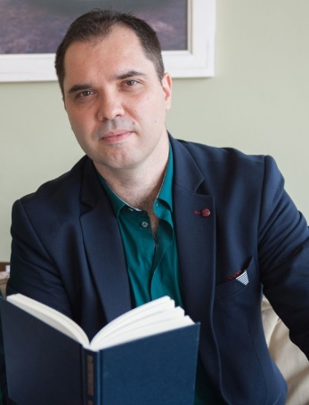
Anton Aleksandrov
CEDR Panel Admission: 2020
Languages: English, Bulgarian

“Anton was a very patient mediator and his diplomacy kept the conversation going even when I thought I would leave the table. I appreciate his polite way to focus on the important things, and make us see the situation from the outside. The most suitable word for his way of work is reliable.”
Client Feedback

Overview
Anton Aleksandrov is a mediator and lawyer (with over 15 years legal practice and 8 years as a mediator). His experience as a mediator is in all types of contractual mediations, IT, Energy, Construction, and commercial issues, real estate, and family mediations. His practice as a lawyer in the last years is mainly focused on assisting clients achieve settlements in all types of civil and commercial contracts, e.g. works contracts, construction contracts, property disputes, disputes between partners in a company, family disputes.

He is also a mediation trainer with more than 5 years of experience and more than 250 trained mediators, and a trainer in negotiation and dispute resolution.

In addition to that, he served as a mediator at the first and biggest court Settlement Centre at the Sofia Regional Court for more than 8 years (from its establishment in 2010 to 2018). The Court Settlement Centre was acknowledged as a model by the European Parliament in its Resolution (2011/2026(INI)).

He also participated in a variety of initiatives promoting mediation, e.g. professional events for lawyers, educational events for school principals, video and TV mediations, etc.
Currently, he is the Vice-President of SPORAZUMENIA (Agreements) ASSOCIATION, Sofia, Bulgaria.

Dispute resolution experience
- Mediator in Civil and Commercial disputes, IT, Energy, Construction, Partnership/Shareholder disputes, Landlord & Tenant cases, Property and Partition disputes, Consumer disputes, Matrimonial cases, in particular:
  - Served 8 years at the Court Settlement Centre at the Sofia City court,
  - Practiced as a mediator in private centres, with focus on commercial and civil cases, mostly related to breach of contracts, defects, misunderstandings around the interpretation of contractual obligations, and commercial contracts.
- Lawyer with practice in Civil and Commercial disputes, and out-of-court settlement.
- Mediation and Negotiation Trainer
Directly involved in the development and delivery of certification and professional trainings in the field of conflict resolution and mediation, for more than 600 professionals, in particular:
  - Certification trainings for Mediators – with more than 250 trained mediators, Trainings in Family Mediation, Business Mediation,
  - Trainings for Lawyers and Managers - in Negotiation and Persuasion at work and in business, including for CEO’s and HR managers (2018, 2019, 2020)
Professional background
Sworn Translator, 2002-present
Sworn Translator from English to Bulgarian and vice versa, with 18-year experience, including as a subcontractor under contracts awarded by the European Commission, the European Parliament and the Council, the EU Court of Justice and the European Court of Human Rights, both translation and interpreting, including in court, notary and arbitration proceedings.

Attorney-at-Law (2004 – present)
Registered at the Sofia Bar Association. Legal practice mainly focused on Contractual law, Corporate, Commercial Law, Real Estate Law, and ADR, special focus on negotiating and saving difficult transactions, and representing clients in resolving disputes.

Mediation Style
Anton’s style has been assessed as very facilitative and diplomatic, as he kindly reframes parties’ complaints to help them focus on future possibilities. He is patient when listening to parties and at the same time he guides parties to elaborate a practical decision within a short term.

