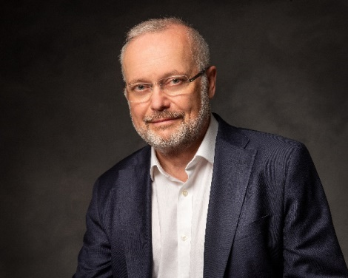
Ralf Lindbäck
CEDR Panel Admission: 2020
Languages: English, Finnish, Swedish

Overview
Since graduating (LL.M) from the Helsinki University in Finland, I have successfully followed a career specializing in legal matters relating to the international energy sector and the maritime industry.
My work as lead in-house counsel and management team member in a listed global corporation has given me considerable involvement in negotiating complex transactions as well as lifecycle services solutions, while also enhancing my reputation and track record in restoring business relationships, conflict prevention and early dispute resolution. Working with foreign administrations and global clients has further broadened my understanding of different legal systems.
I am a Member of the Finnish Arbitration Association (Helsinki), the Collaboration Council of CEDR (London), the European Advisory Board of the International Institute for Conflict Prevention & Resolution (New York) and the Chartered Institute of Arbitrators (London).
Summary of Dispute Resolution Experience
My experience from working with cross-border dispute resolution and arbitration as in-house counsel and coordinator include, amongst others:
- Settlement of a case after challenging arbitration venue and jurisdiction. Claimants presented broad allegations and claims under multiple agreements (supply and services) for breach of contract.
- Multiple claims/counterclaims (subject to arbitration) for costs and consequential losses because of delays in a project were handed over for adjudication. The case was settled five months after the decision by the adjudicator.
- Substantial claims for damages, loss of revenues and penalties due to breakdown of equipment. ICC arbitration proceedings were initiated, and statements of defense were exchanged. The parties entered settlement negotiations and the case was resolved a year later.
- Recovery claim (based on subrogated rights) by the main underwriter against equipment supplier for loss paid under a machinery breakdown policy. After initiated arbitration proceedings, the parties agreed explore ADR methods. The case was finally resolved through mediation.
- Claim for damages because of negligent performance of maintenance/service work. Key procedural issues included venue, language, and confidentiality. The case was settled through mediation.
Professional Background
Wärtsilä Corporation (1994 − )
Recent accomplishments in Wärtsilä: Developing and implementing a cost effective and non-disruptive claims and dispute management process for early identification, intervention, and resolution of issues in dispute to preserve business relationships. The process won the Financial Times’ ‘Innovative Lawyers Award − Europe 2018’ (Innovation in the business of law and operations - Data, knowledge, and intelligence).
Managing Counsel, Dispute, Insurance and Trade Management, Marine | Wärtsilä Corporation | 2019−
Vice President, Legal, Services | Wärtsilä Corporation | 2006−2018
Before 2006: General Counsel, Wartsila North America Inc. (1998−2002), Legal Counsel, Wärtsilä Finland Oy (1994−1998, 2002−2006), Head of Legal Department, The Finnish Marine Insurance Co Ltd (1988−1994), Research Assistant, University of Oslo − The Scandinavian Institute of Maritime Law (1988), Training on the Bench, Raseborg District Court (1986−1987).

Mediator Accreditation and ADR Training
Mediator Accreditation | CEDR  CIArb | 2017  2019
Arbitrator Training | The Arbitration Institute of the Finland Chamber of Commerce, ‘The Finnish Arbitration Academy’ | 2016
Special Courses in ADR | Université de Genève, Faculté de Droit, ‘The International Dispute Settlement (MIDS) program’ | 2014−2015

Education
The Lausanne Leadership Program (LLP) | IMD – International Institute for Management Development | 2011 and  2001
LL.M. | University of Helsinki – Faculty of Law | 1985
Special line examinations (1985−1989): The University of Cambridge – Board of Extra-mural Studies (‘English Legal Methods’), the University of Oslo – The Scandinavian Institute of Maritime Law (‘Maritime Law and Oil & Gas Law’) and the University of Southampton – Institute of Maritime Law (‘The International Sale of Goods Carried by Sea’)

Awards, Honors and Assignments, Languages

Awards | FT Innovative Lawyers Award − Europe 2018 (Innovation in the business of law and operations – Data, knowledge, and intelligence) | 2018
Honors | Knight of the Order of the Lion of Finland for significant civilian merit by the President of Finland | 2013
Assignments | Member of the International Chamber of Commerce (ICC) ‘Task Force on ADR and Arbitration’ | 2020 −
Pro Bono | Mediation (51 cases / 63 sessions) | 2018 −
Languages | English (fluent), Finnish and Swedish (bilingual), Norwegian (proficient)

Mediation Style
Profound preparation for the mediation is necessary to identify past, present, and future aspects that are or may become essential to resolve issues in dispute between the parties. I am open to case specific process suggestions form the parties, however, if the case or situation calls for it, I am procedurally directive.
I use private meetings and shuttle between the parties to develop the conditions that will enable them to return to and resolve their disputes in joint sessions. Any input on content and substantive issues is limited to well formulated open questions challenging realities.

Wärtsilä is a global leader in smart technologies and complete lifecycle solutions for the marine and energy markets. By emphasising sustainable innovation, total efficiency, and data analytics, Wärtsilä maximises the environmental and economic performance of the vessels and power plants of its customers. The company has operations in over 200 locations in more than 80 countries around the world. Wärtsilä is listed on Nasdaq Helsinki. www.wartsila.com

