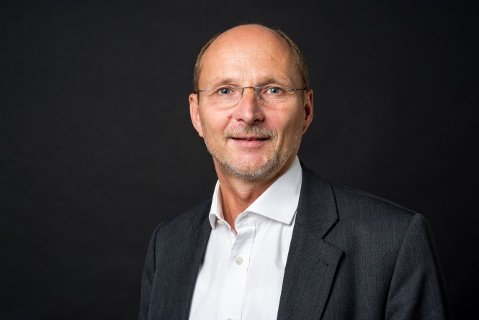
Klaus-Olaf Zehle
CEDR Panel Admission: 2020

“It was only through Klaus-Olaf Zehle as mediator that it became possible to channel the conflicts in our group of shareholders and to develop jointly supported solutions.”

Overview
Klaus-Olaf Zehle is working as a mediator since 2005, during which time he has conducted more than 150 mediations. Also he has conducted 30 large conflict moderations since 2004. His mediation areas are conflicts between stakeholders in large companies or family owned enterprises i.e, shareholders, unions, employees - conflicts in StartUp companies - conflicts in IT and telecommunication projects - conflicts in outsourcing contracts. He has industry experience in transport, logistics, tourism, software, telecommunication, IT-Services, engineering and media.
He published an empirical analysis on commercial dispute resolution practices in German corporations and about the effects of the German mediation law for commercial disputes.
He is listed as distinguished neutral at CPR since 2005, certified mediator at IMI, certified mediator according to § 5 Abs. 2 MediationsG and member of mediation services at Hamburg chamber of commerce.
His qualification is based on master degrees in economics, engineering, laws and mediation.
He is founder and managing director of Mediation GmbH, the largest mediators directory in Germany.
He is also founder and managing partner of the consulting company EQUIDIS. EQUIDIS is offering equidistance consulting, with methodologies based on mediation.
Besides to mediation services and equidistance consulting he works as business coach, leadership trainer and human resource consultant in two recruitment firms
Klaus-Olaf regularly mediates in German and in English.

Dispute resolution experience
Information Communication and Technology
- Mediation between shareholders, founders and employees of several companies in the telecommunication and technology sector
- Mediation between contract partners in outsourcing and service agreements
Media & Enterntainment
- Dispute resolution in the management team of a digital and media agency. Process consutling and strategy implementation.
Construction & Engineering
- Mediation of several disputes in the managemement team of a large engineering provider in the Automotive industry
- Mediation between workers force and management in a construction company
Charities
- Mediation between choirmasters and the board of directors in several choruses
Contractual disputes
- Several mediation on working contract issues and shareholder contract issues.

Professional background
Mediation GmbH Managing Director
(since 2011)
EQUIDIS GmbH Managing Partner
(since 2009)
AIMS International Associated Partner
(since 2017)
Management Angels GmbH Managing Director (07/14-06/17)
(since 2014) Partner (since 07/17)
LIGA Management Partner
Consultants (2004-2009)
TietoEnator Consulting GmbH Managing Director
(2000-2003)
INFO AG France Telecom Board Member (CSO/CMO)
(1992-1999) (Sales, Marketing, Productmanagement, Consulting, HR & HR development)
Enator Deutschland GmbH Deputy Managing Director
(1985-1991) Head of sales & marketing
Senior Consultant, Projectmanager
Mediation Style
His mediation style is evaluative, sometimes also facilitative. Sometimes he makes use of caucusing.
Since 2019 he is offering online mediation services using several platforms.

