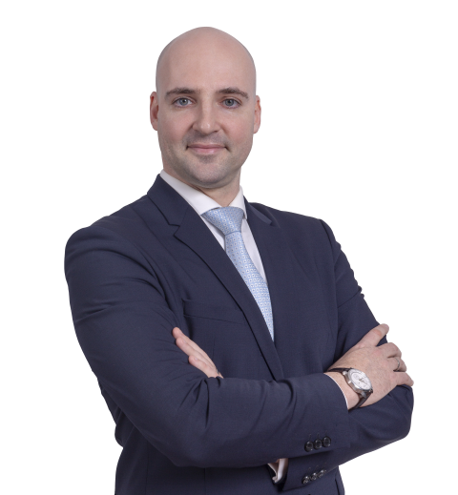
Thomas Gaultier
CEDR Panel Admission: 2020
Languages:English, Portuguese, French

Overview
Thomas is a New York qualified attorney and counsellor-at-law, currently Of Counsel at Abreu Advogados in Lisbon. He is a graduate from the University of Paris X Nanterre Law School.
He has an LL.M in Alternative Dispute Resolution of the University of Texas in Austin, during which he became a certified mediator, and where he participated in the Graduate Portfolio Program in Alternative Dispute Resolution, presenting his research on "Cyber- Arbitration".
He has authored various articles and book chapters on the topic of mediation and ADR, including an award-winning paper entitled "Cross-Border Commercial Mediation".
He is the Vice-President and co-founder of the ICFML – Instituto de Certificação e formação de Mediadores Lusófonos, a non-profit organization aimed at training and certifying Portuguese-speaking mediators.
Thomas also teaches mediation and negotiation in Portugal’s best law schools.
Summary of Dispute resolution experience
Thomas has acted in many proceedings, as a mediator or as settlement counsel, in diverse areas:
As Mediator:  - Construction /Engineering  - Distribution / Agency  - Sale of Goods  - Intra-company conflicts  - Insurance claims | As Settlement Counsel:  - Energy Projects  - Construction /Engineering  - Structured Finance  - Insurance Claims  - Purchase and Sales of Businesses
Professional Background
Independent Mediator, Lisbon, Portugal
Since 2010

Of-Counsel at Abreu Advogados, Lisbon, Portugal
September 2010 to May 2012, and since April 2015
- Practice focused on dispute resolution as settlement counsel, contract management in energy and construction projects and international transactional and corporate law.

Of-Counsel at AAA Advogados, Lisbon, Portugal
June 2013 to January 2015
- Practice focused on international corporate and commercial law, structured finance and international corporate reorganisation, as well as dispute Resolution as settlement counsel in conflicts related to financial transaction.

Of-Counsel at Miranda, Correia, Amendoeira & Associados, Lisbon, Portugal
May 2012 to May 2013
- Practice focused on oil and gas issues in sub-Saharan Africa, namely, company law, import/export, customs, finance and labour law.
- 2-month rotation in the Republic of the Congo.

Co-founder and Vice-President of the ICFML - Instituto de Certificação e Formação de Mediadores Lusófonos, Lisbon, Portugal
Since December 2011
- Coordinator and trainer in public and private civil and commercial Mediation as well as in insolvency mediation.

Personal Mediation Style
When mediating, Thomas is primarily facilitative, meaning that he will encourage and assist Parties in finding themselves the options and possible solution to their problem. However, if asked by the Parties, and agreed to by both, he is equally comfortable intervening more in the sense of brining constructive feedback to any options brought by the Parties, as well as helping them come up with addition paths for the mediation to be more productive.
As a mediator, Thomas always strives to follow the principles of a constructive negotiation, namely, the promotion of respectful communication, tackling of all relevant questions, putting the situation into perspective, managing existing risks and building a collaborative relationship.
Academic background
New York Bar, Attorney and Counsellor at Law, licensed with the New York Bar since 2012.
L.L.M., Alternative dispute resolution and International Contract Law, The University of Texas at Austin, Austin, Texas, USA – 2008 – 2009
Graduate Portfolio Program in Alternative Dispute Resolution, The University of Texas at Austin, Austin, Texas, USA – 2009,.
Master Bilingue des Droits de l'Europe Université Paris X Nanterre, Nanterre, France – 2008, focus in international Commercial Law
Bachelor in French and Anglo-Saxon Law, Université Paris X Nanterre, Nanterre, France – 2007

TEACHING AND TRAINING EXPERIENCE
Lecturer at the Escola de Direito do Porto of the Universidade Católica Portuguesa, Porto, Portugal
Since 2014
Multiple classes taught at undergrad level in Law School: “Negotiation and Decision Making in the Legal World” (5ECTS), “Mediation as an Alternative Means of Dispute Resolution” (5ECTS), “International Commercial Negotiation” (2,5 ECTS), “Introduction to Law and Technology” (5 ECTS) e “Common Law Contracts and Sales” (5 ECTS), among others.

ICFML Trainer for Insolvency Mediation, Lisbon, Leiria, Porto, Online
Since January 2019
Mediation trainer in the first 7 Insolvency Mediation courses recognized by the Ministry of Justice.

Mediation trainer at the Escola de Direito do Porto of the Universidade Católica Portuguesa, Lisbon, Portugal
Since Janeiro 2013
Trainer in a post-graduate program in Civil and Commercial Mediation, with dual certification (public and private).

Lecturer in Mediation at the Faculdade de Direito of the Universidade Nova de Lisboa, Lisbon, Portugal
Academic year 2015-2016
Tought two Mediation classes in the first edition of the Masters in Arbitration and Procedural Law: “Introduction to Mediation” (8 ECTS) and “Mediation – Technique and Practice” (8 ECTS).
Publications
Mediation: Creating Value in International Intellectual Property Disputes - Contribution on intercultural aspects of IP mediation - Kluwer Law International - March 2018
Statute of Limitations in International Commercial Claims, by David Franklin - Portugal Chapter, Carswell - Thomson Reuters Canada - Aug 30, 2016
How to Master Commercial Mediation, by David Richbell - Contribution on Portugal, Bloomsbury Professional, January 1, 2015
Portugal Chapter of “The varied landscape of mediation regulation - A comparative study in Europe and the World”, Manon Schonewille & Dr. Fred Schonewille Editing– July 2014
“Cross-Border Mediation – A New Solution for International Commercial Dispute settlement”, NYSBA International Law Practicum – Spring 2013 edition
“The Long Awaited Portuguese Mediation Law - Fundamental Principles”, YAR - Young Arbitration Review - Edition 10, July 2013
Portugal Chapter of “EU Mediation Law and Practice”, Oxford University Press – published on October 4, 2012
“Is This the Right Time to Sell? Legal Issues and Considerations Regarding the Upcoming Privatizations in Portugal”, NYSBA - New York International Chapter News, December 2011
“France's Arbitration Law: v.2.0”
YAR - Young Arbitration Review - Edition 1, April 2011

Membership
Member of the Union Internationale des Avocats – Vice President of the Mediation and Conflict Prevention Commission - since 2015

