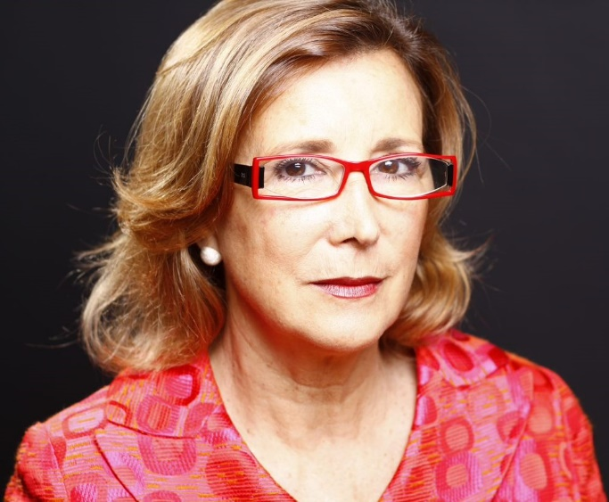 | CEDR Accreditation:  CEDR Panel Member:  Languages:  Location: | 2014  2020  Spanish  Spain

Maite Usón
OVERVIEW
Her professional experience is based on three pillars: consultancy, training and helping managers and organizations in conflict management.
This expertise together with her mathematical and business background and her experience in ICT consultancy, skills training and professional coaching have allowed her to develop a methodology to train mediators in more than 20 Spanish speaking university institutions during the last 10 years.
She has been involved in the development of mediation in Spain for 20 years and has learned in situ the procedure for the implementation of ADR in the Anglo-Saxon world (UK, USA, Canada) and in Latin America (Mexico, Colombia, Peru, Chile and Argentina).
EXPERTISE (dispute experience examples)
Employment & Workplace
Large experience in individual coaching of senior managers in personal conflicts with the organisation. Since every case implies reaching a settlement that is appropriate and sensible for both sides, much of my work has been focused on preserving relationships between parties in dispute, where possible.
General contracts
Settlement of conflicts in commercial property leases

Personal Style
She is used to handling complexity in technical, business and human dimensions and knows how to help the parties to recognize the most relevant factors, generate various perspectives and seek out solutions.
Maite is an energetic person who conveys passion, optimism, and pragmatism
Professional skills
Born in Barcelona, Spain, although most of her professional life has taken place in her hometown, she has travelled professionally throughout Europe, Latin America and the United States, where she lived for two years.

Professional Experience:
- Mediator trainer in competence development, in various institutions, universities, professional associations and collaborator with CEDR (2008 - present)
- Mediator Neutrales-Jams International
- ESADE Business School. Professor-Collaborator (1975 - present)
- BPI Group, experts in HR. Manager and Senior Consultant (2005-2010)
- ESADE Business School Alumni. Director (2002- 2005)
- Accenture (Andersen Consulting) (1989-1996). Consultant Manager in banking and change management. 1994-1995 at the HQ in Chicago.
- AIS (Artificial Intelligence Applications). Consultant in the banking sector (1987-1989)
- ESADE Business School. Professor of Mathematics and Statistics (1983-89)
- University of Barcelona. Professor of Statistics (1975-81)

Studies and qualifications:
- Master in Business Administration. ESADE Business School. Barcelona.1985
- Bachelor of Arts in Mathematics. University of Barcelona.1975
- Certified Coach ACC, ICF Internacional. 2008
- Master Practitioner NLP (Richard Bandler). 2017
- Accredited Mediator CEDR (UK). 2015

