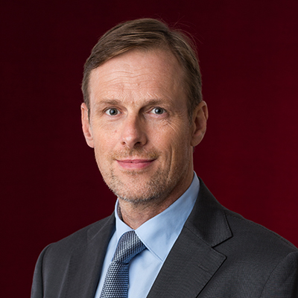
Joost Maassen
CEDR Panel Admission: 2020
Languages:English, Dutch, German

Motto: “I have made a ceaseless effort not to ridicule, not to bewail, not to scorn human actions, but to understand them.” (Baruch Spinoza)

Overview & Professional background
Specialist for negotiations and alternative/effective dispute resolution (mediation) in (international) commercial, corporate and employment matters.
Dutch lawyer of German origin. Mother tongues Dutch and German, fluent in English, good command of French and Spanish.
Worked in (international) litigation and arbitration as an attorney with a leading Dutch law firm (De Brauw Blackstone Westbroek).
Experience as (international) management consultant and co-owner of an executive search firm (YESS International Consultants, at the time the young executive branch of Egon Zender International).
Dutch and English mediation qualifications (MfN - Mediators federatie Nederland and CEDR - Centre for Effective Dispute Resolution, London).
Experience relating to effective conflict prevention, -management and -resolution as independent and impartial mediator, party advisor, trainer, coach and (management) consultant.
Currently working from Bussum in The Netherlands (close to Amsterdam), with the mediation, consulting & training firm Dialogue B.V.

Summary of Dispute resolution experience
Experience as a mediator in commercial, corporate and employment matters, in over 200 cases, such as:
- Claims and counterclaims between receiver and creditors in bankruptcy proceedings
- Claims and counterclaims between banks and a former clients of the bank
- Disputes relating to control of legal entities/corporations (both profit and not-for profit) between shareholders, executive and non-executive directors
- Employment disputes, both collaboration and performance issues and relating to rescission of contracts at executive, senior and middle management level
- Disputes between unions and/or works councils and employers (‘ organizations)
- Disputes between developers and contractors relating to real estate projects
- Disputes within professional partnerships (attorneys, medical doctors, notaries, accountants, management consultants)
- Disputes relating to recreational real estate, between owners of holiday homes, the board, and the corporation which exploits the resort commercially
- Dispute between international parties relating to movable registered goods
Experience as an attorney with a leading Dutch law firm, De Brauw Blackstone Westbroek, representing clients in (international) litigation and arbitration in (international) commercial, corporate and employment matters, such as
- Representing a German listed company in arbitration proceedings brought by US company for breach of contract relating to the construction of an innovative plant in the Rotterdam Harbour, claim US $ 50 million
- Representing an English buyer of a Dutch company in post acquisition warranty claims arbitration
- Representing an English/Dutch oil company as claimant in an arbitration against a Norwegian contractor, for damages resulting from a damaged oil well
- Representing Austrian party who bought fine art (sculpture) in the Netherlands, which proved to be counterfeit, in proceedings in civil court
- Labour and employment disputes
Personal Mediation Style
In disputes and difficult negotiations the decision making process is impaired by an interplay between strong, ineffective emotions, lack of understanding and lack of information.
Joost mediates in facilitative style, remaining independent, impartial and without expressing his opinion about or giving advice on the content or legal aspects of the matter.
He aims to improve the parties own decision process. He does this primarily by setting up a process which allows all parties concerned to improve their understanding of both the other parties and of their own positions, needs and alternatives to any possible agreement.
Joost is firm on process and respectful of the parties autonomy regarding content; what they wish to discuss, propose, reject and agree or disagree upon. By safeguarding a transparent, confidential and without prejudice nature of the process Joost aims to create a safe environment for parties to express themselves and to share information, without undue risk.
By fostering mutual understanding and by both recognizing (himself), and by improving recognition between the parties, of what the matter means to each of them, Joost aims to ameliorate the parties willingness to collaborate towards mutually acceptable outcomes.
His business and legal background gives Joost a better understanding of legal and business implications of disputes. He balances this with a keen eye for the human dimension of conflict, and a sense of humour, where and when appropriate.
Joost prefers to have individual intakes with each party. He works with a mix of joint and private sessions. He has experience with on-line mediations.
In most mediations Joost conducts the parties have legal advisors, either at the table, or in the background. Having been a litigation attorney himself, Joost has the necessary experience to support parties and their legal advisors to improve the decision making process, without reverting to mere position pleading on the basis of purely legal arguments.

