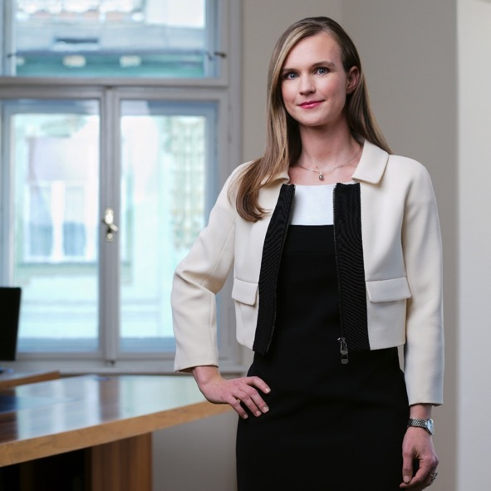
Iris Pensa
CEDR Panel Admission: 2020
Languages:English, Slovenian

Overview & Professional background
After traineeship at the Law Office Jadek & Pensa and at Orrick, Rambaud, Martel Law Office in Paris Iris continued to work for Law Office Jadek & Pensa and became Attorney at Law in 2012 and Managing Associate in 2019.
Iris successfully completed Approved Mediation Training at Judicial Training Centre of Republic of Slovenia, Ljubljana (2012) and become mediator in 2012. Iris is listed as mediator on the list of mediators of the Mediation Centre at Slovenian Bar Association from 2017. In 2018 Iris was elected as mediator in individual employment disputes between employers and employees in law offices at Slovenian Bar Association.
In the law office, Iris works in the Prevention and Resolution of Dispute unit. In her work, she advises the parties on a daily basis regarding the settlement of disputes, negotiates a peaceful settlement of disputes and prepares settlement agreements in all legal fields. She regularly attends mediation meetings as a representative of one of the parties. She is most content when the parties manage to agree on an amicable settlement of the dispute.
As part of her duties as a mediator in the Law Office Jadek & Pensa, she also mediates since 2012. She has conducted successful mediations in the field of family law (division of joint property) and labour law.
Iris is also a member of Slovenian Bar, Member of Slovenian Association of Mediators

Summary of Dispute resolution experience
Main areas of activity:
Human Rights Law,
Labour Law,
Prevention and Resolution of Disputes, Mediation,
Intellectual Property
Experience include:
- Work place mediations for a production company employing over 800 employees regarding behavioural issues, termination of contracts and role of Works Council.
- Mediations in matrimonial disputes regarding the division of joint property.
- Assisting in negotiations, conciliations and consultations in the collective bargaining.
- Assisting in negotiations, conciliations and consultations with the Union and Works Council in mass lay of procedures.
- Solving disputes arising from transport contracts (including rail transport and maritime transport), commercial contracts (IT sector, construction, sale of goods and services), shareholder agreements, intellectual property rights (trademarks, copyrights), terminations of employment and inheritance with amicable settlement agreements.
Publications:
Discrimination in Criteria for Payment of Performance Bonuses, Podjetje in delo - A Journal for Commercial, Labour and Social Law No. 8, 2019; Gender pay gap, discriminatory business performance bonuses, Direktor Magazine, No. 43, 2019​; Women, Business and the Law 2020 report (contributor for Slovenia 2019); Doing Business 2020 Labor Market Regulation (contributor for Slovenia 2019); WJP Rule of Law Index® 2020 (contributor for Slovenia 2019); How to avoid succession disputes, Direktor Magazine, No. 37, 2019; Doing Business 2019 - Labor Market Regulation (contributor for Slovenia 2018); World justice project Rule of law index: 2018-2019 (contributor for Slovenia 2018); Mediation – Resolution of Disputes at Party’s Will not at Judge’s Discretion Delo: Svet kapitala, December 2017
Personal Mediation Style
Iris practices facilitative mediation. In her opinion the main advantage of mediation is that the parties themselves can decide on the matter and on the resolution of dispute. Thus, Iris mainly engages parties in conversation to understand their interests and point of view. Iris also strongly believes that as life is dynamic and everything is changing constantly. This dynamic has an effect on relations between parties in a dispute, although the dispute arises from historical events. Iris therefore focuses on searching for solutions for the future and tries to avoid too much discussions on the past events which have caused the dispute, as this is always stressful, and stress often hinders rational decisions and only deepens the dispute.

