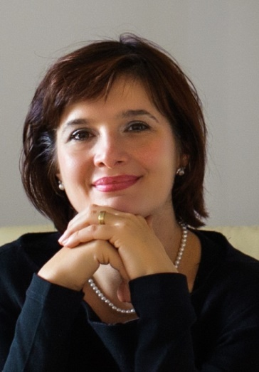
Soriana Constantinescu
CEDR Panel Admission: 2020
Languages:English, Romanian

Overview
Soriana’s practice contains a variety of cases, many of which concern commercial matters, property, financial services, workplace, Mergers &Acquisitions, shareholders disputes. Her clients range from private individuals through national and international organizations. Soriana is a mediator authorized by the Mediation Council in Romania and accredited by the Centre for Effective Dispute Resolution (CEDR) UK.
Summary of Dispute resolution experience
Banking and Finance
- Debt management and recovery
- Loans and mortgages
- Insurance claim

Property
- Land ownership
- Landlord and tenant
- Boundary disputes
- Right of way
- Lease renegotiation
Commercial
- Contractual disputes
- Platform implementation
- Intellectual Property
- M&A
- Sales of goods
- Warranties
- Data Protection
Construction
Developers, contractors and subcontractors disputes
Employment and workplace
- Termination of contract
- Discrimination
- Performance

Professional Background
Soriana has a broad experience of over 25 years, acquired in companies operating in various industries (financial services; pharmaceuticals; natural supplements; real estate acquisitions and development; construction; mineral aggregates extraction and distribution; production units; migrants economic integrations; call centers), within start-ups, SME’s, group of companies and multinationals.
Her expertise developed in a diverse and multicultural environment and includes the following areas: international and national project management and implementation, business administration and development, mergers and acquisitions, real estate acquisitions and development, negotiation and mediation, data protection and investigations.
The on field experience and perspective gained through the performance in various roles (administrator, director, business consultant, business developer, project manager) lead her remarkable results including:
- Starting-up, coordination, management and strategic development of a financial services company, from t0 to breakeven point and further to the profit stage.
- M&A experience, in pharmaceuticals transactions above 40 mil Euro

Personal Mediation Style
Soriana’s mediation style enhances the parties’ abilities to solve their conflict.
By asking relevant questions she creates meaningful discussions that gently move the parties focus from how the conflict was created, to the future practical options available.
She creates a trustful environment that encourages the parties to express their emotions, to find the other party perspective without while keeping their focus on shaping an workable outcome that will satisfy them.

Client Feedback
“She is open minded, hard worker and dedicated to her clients”
“Soriana has a strong ethical approach and strong skills in effective intercultural communication.”

