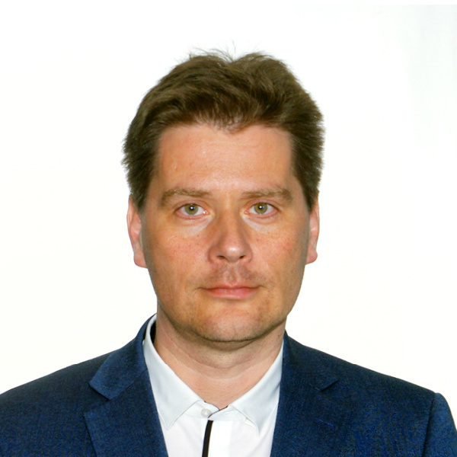

CEDR Accreditation: 2012
CEDR Panel Admission: 2020
Languages: English | Hungarian
Location: Budapest, Hungary

Balint Balassa

Overview
Balint is the most renown expert and mediator in the field of conflict resolution within the Office of the Ombudsman at the United Nations High Commissioner for Refugees (UNHCR). He has to his credit over 500 resolved cases ranging from highly escalated interpersonal conflicts, contractual and regulatory issues, professional negligence, health and reputation related grievances.
In addition to his excellent conflict management skills, Balint has a solid education background with 16 years of teaching experience as an instructional designer in both public and private education sectors as well as in human resources development. Working in collaboration with CEDR, Balint coordinated the design and implementation of UNHCR’s Conflict management training package which has been widely delivered accross the globe. The innovative and experiential trainings he designed and conducted mainly focus on conflict management techniques and mediation in an international context with an emphasis on the psychological implications of conflicts, inter-cultural communication and negotiation.
In his current practice as a workplace mediator, he mainly deals with disputes involving employees, teams, individual partners and partner agencies as well as individuals outside of the organization. Balint has successfully led and designed several team interventions around the world in different UNHCR field locations in Asia, Africa, the Middle East, Latin America and Europe.
Balint is a certified mediator since 2012. He is a member of the International Ombudsman Association since 2016. Balint holds a degree in Psychology and in Education. He regularly holds trainings and gives lectures on conflict related topics within and outside his organization. He has contributed to various publications as an editor, author or specialist.
Balint speaks both English and Hungarian and is comfortable mediating in both languages.
Dispute resolution experience
Public Sector
- Negotiations between an educational institution and government representatives
- Highly escalated team conflict in an international humanitarian organization

Professional Negligence
- Dispute on alleged professional negligence
- Mediation in conflict related to financial loss as a result of professional negligence
Reputation management
- Threats of reputational damage based on misinterpretation of information
- Facilitation of discussion in conflict related to spreading malicious gossips
Contractual Disputes
- Mediation of interpersonal conflict resulting in non-extension of contract
- Mediation of challenging performance related contract termination
- Mediation of disagreement on interpretation and application of organizational policies
Employment & workplace
- Mediation in interpersonal workplace conflicts
- Dispute between management and team members
- Performance evaluation disputes in a global setting
- Procedural shortcomings in competition for assignment

Personal injuries
- Dispute about expenses of medical treatment in work-related injury
Professional background
2016-: Mediator and Conflict Resolution Officer - Ombudsman’s Office, Office of the United Nations High Commissioner for Refugees (UNHCR), Budapest, Hungary
2015: Staff Development Officer, trainer, instructional designer - World Intellectual Property Organization (WIPO), Geneva, Switzerland
2009 – 2015: Assistant Staff Development Officer, trainer, instructional designer - Office of the United Nations High Commissioner for Refugees (UNHCR), Budapest, Hungary
2005 – 2009: Teacher of Methodology, Literature, Rhetoric and Creative Writing - Torok Sandor Waldorf Teacher Training Institution, Solymar, Hungary
1996 – 2009: Class Teacher, High School Literature Teacher and Primary School English Teacher, Chair of the Teacher`s Board, Pesthidegkut Waldorf School, Budapest, Hungary

Studies and Qualifications
2019 Bachelor’s in Psychology, University of Debrecen, Hungary
2016 Certification in Foundations of Organizational Ombudsman Practice, Seattle, USA
2014 Certification in Organizational Network Analysis, Budapest, Hungary
2012 CEDR Accredited Mediator
2012 Cross-Cultural Coach, Prague, Czech Republic
2011 Certification of the UNHCR Trainer and Facilitator Development Program, Budapest, Hungary
1999 Masters in Literature, Hungarian Language and Education - Eotvos Lorand University, Hungary
1993 Certification of class teacher - Emerson College (United Kingdom)

Conferences, lectures, publications
Conflict as a Crisis – Three Misbeliefs About Conflict Management
Study in Preventing and Managing Crises, Oriold, Budapest 2020 (Author)
The Active Bystander Campaign
European Ombudsman Conference, Geneva, Switzerland 2018 (Presenter)
Where Do We Learn Conflict?
International Ombudsman Association Annual Conference, Minneapolis, USA 2017 (Presenter)
CEDR Negotiation Handbook, 2015 (Specialist contributor)
Re-enactment in Conflict Management
Kassak Museum, Budapest , 2013 (Lecturer)
Mediation Style
Mediation, almost without exception, is preceeded by a tense period of disagreement and feelings of hopelessness. Balint skillfully combines his conflict management and psychological competencies to help the parties overcome the mental effects of the conflict. He makes the parties reflect on their respective situations while helping them to assess and question their perceptions and assumptions to gain a better understanding of their emotions, expectations and behaviour from different perspectives, while actively encouraging the parties to find an agreement through understanding each other.
“Balint listens and takes the time to understand both sides of the dispute. He is objective, fair and compassionate. These qualities and approach to mediation has allowed for an environment of trust where both parties to the conflict (with different power ranking) have been able to come together and work out a satisfactory solution which otherwise would not have been possible.”

