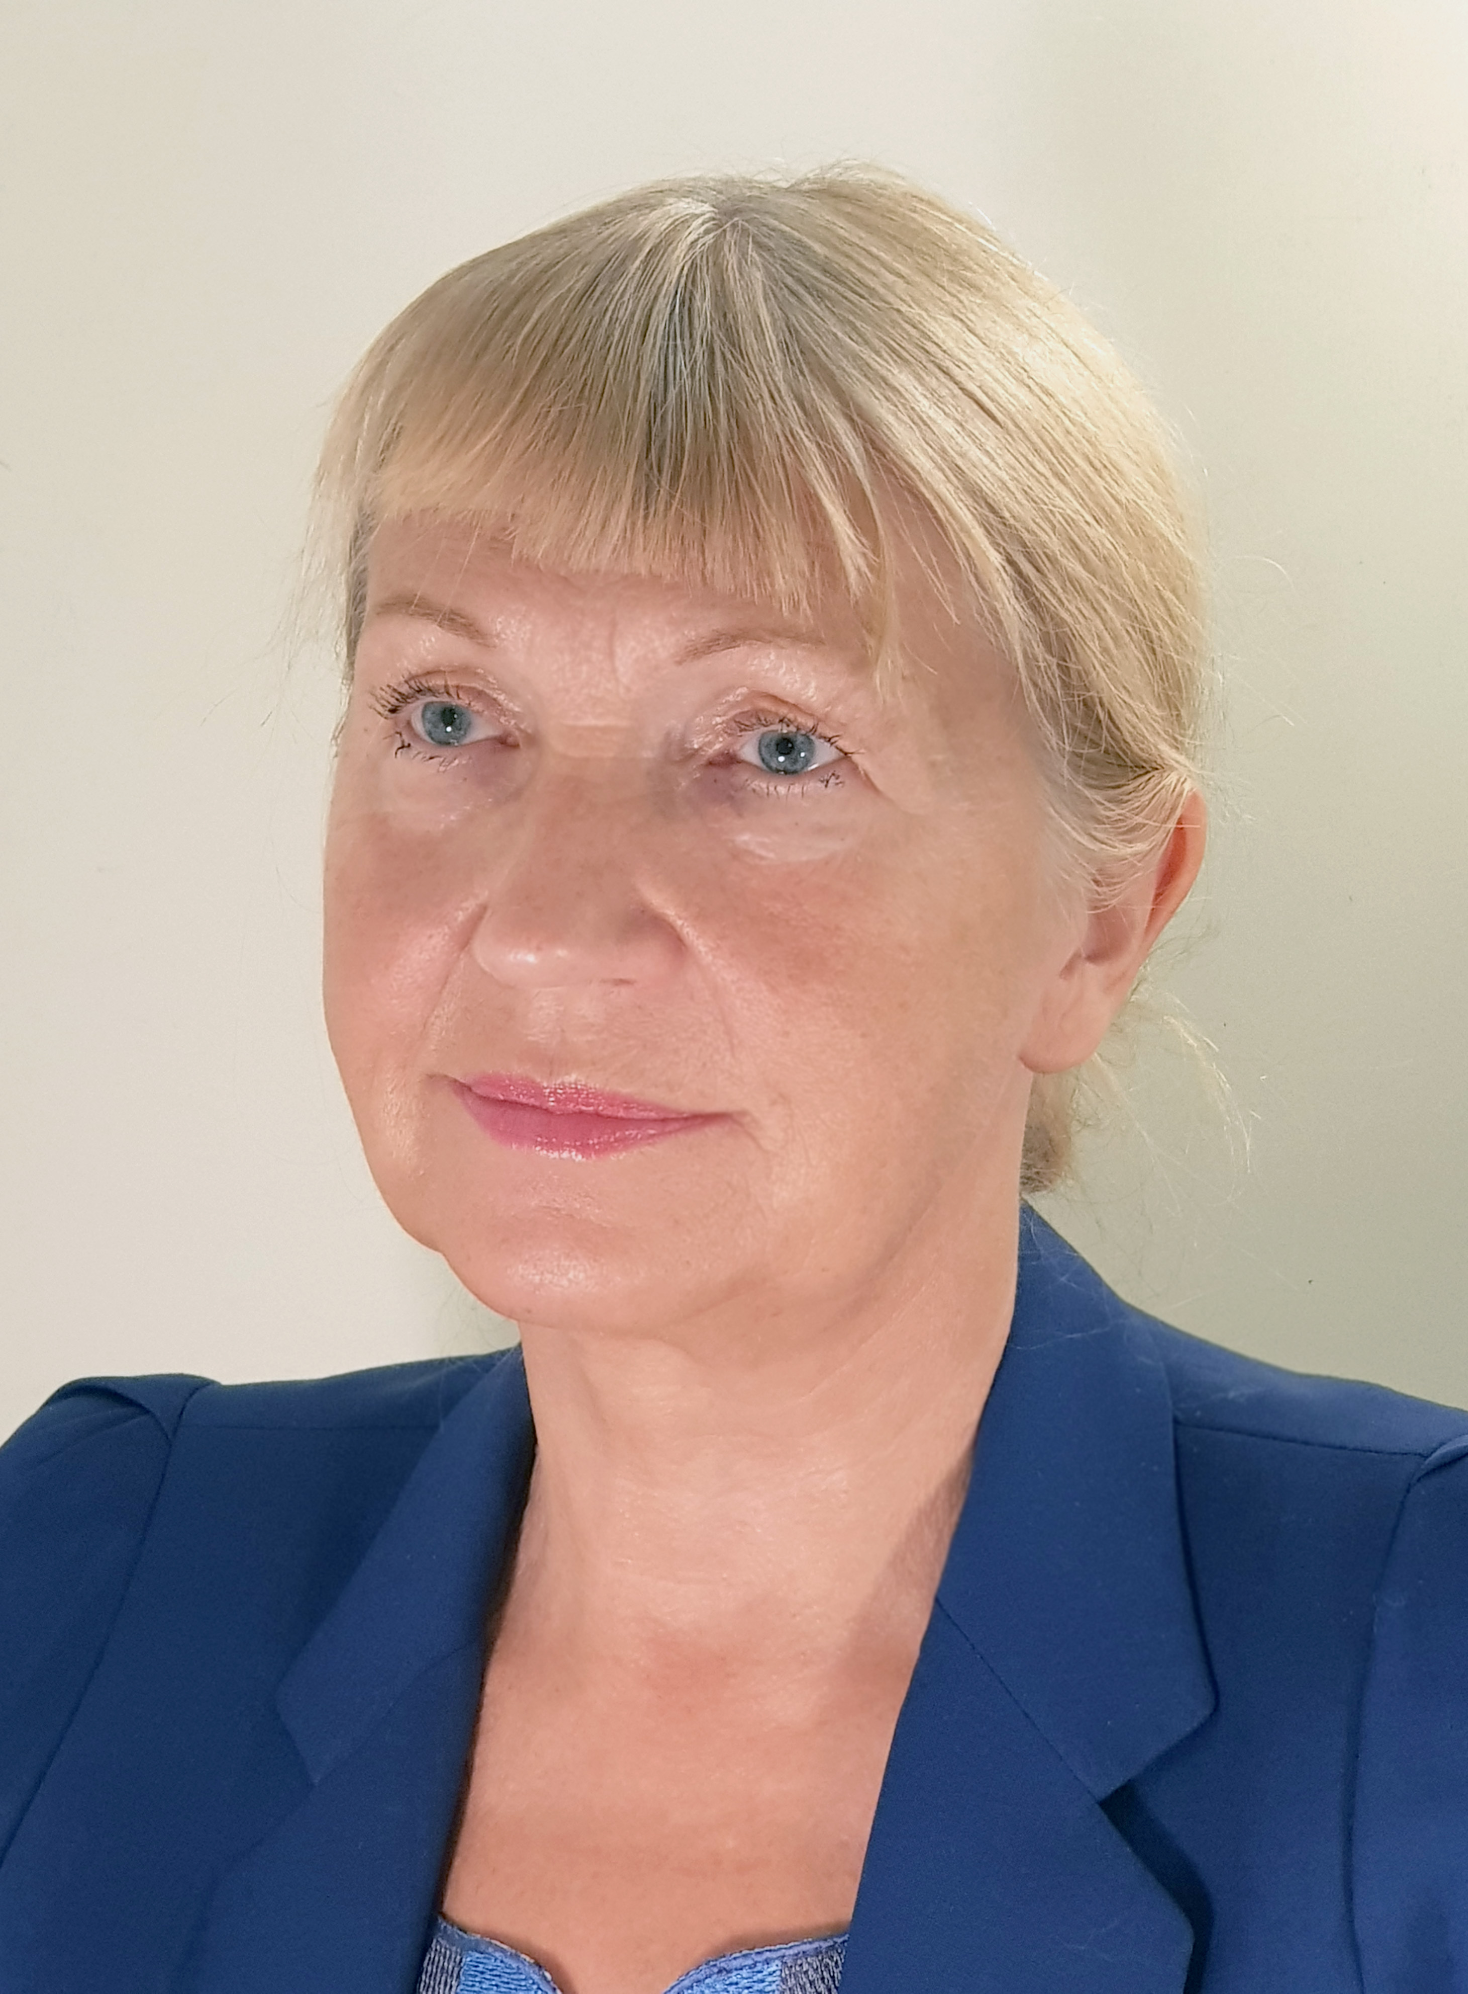
Laima Arija Zelmene
CEDR Panel Admission: 2020

Overview
Laima Arija Zelmene is a lawyer for 26 years and a mediator for 16 years. She is recognised as one of the beginners of mediation techniques in Latvia. She has participated in more than 400 media cases as a mediator.
She is a chairman of the board of the Mediation Council of Latvia. Also, she is one of the co-founders of NGOs “Integration for Society”, “Mediation and ADR”, which play important roles in policy development of mediation in Latvia.
Laima Arija Zelmene is a lecturer of mediation and, more important, she is one of the authors of training programmes for legal practitioners (notaries, judges, bailiffs) and for teachers and pupils ( "Mediation at School", "Organization of the Peer Meditation in School").
Laima can mediate in Latvian and Russian.
Her opinion: There are no unresolved situations if the Parties have aim to resolve them!

Dispute resolution experience
Property
- Disputes among owners over the actual dividing joint property and rights of use, including the determination of criteria for property valuation.
- Neighbor disputes
- Disputes over the construction of new facilities among landowners, residents, public authorities and construction organizations
- Division of property between spouses
Media & Entertainment
Disputes between a media owner, a journalist and a person over the publication of sensitive data.
Charities
Disputes in the environment of non-governmental organizations, development and marketing strategies of these organizations, project and team management, cooperation with state institutions.

Education
- Training of teachers and students on the topics "Mediation at school" and "Peer mediation"
- Dispute resolution in educational institutions between management and employees.
Shipping
All kinds of disputs of Shipping company
Utilities
Disputes between landlords and tenants

Professional background
- 05.12.1994.-present: Sworn Attorney
- 10.2004.-20.10.2014.: Mediator
- 21.10.2014.-present: Certified Mediator
- 06.2007.-present: Lecturer on Mediation
- 07. 06.2011.-31.12.2015.: Mediator at The Riga Orphan's Court, Street Kalēju 78, Riga, LV 1050
- 27.11.2014.-26.11.2020. Vice-Chair of The Council of Certified Mediators, Street Kr.Barona 88, Riga, LV 1001
- 05. 08.2011.-present: Chairman of the Board, Project Manager of the NGO „ Mediation Council”. Street Kr.Barona 88, Riga, LV 1001
- 2003.-present : Vice President, Project Manager of the NGO „Integration for Society”. Babītes Ŗeg., Salas Parish., Silmalas „Ratnieki”, LV-2105
- 2005.-2014.: Chairman of the Board of the NGO „Aediation and ADR”, Street Kr.Barona 88, Riga, LV 1001
- 2006.-present: Board Member of the NGO „SILVA METHOD LATVIA”, Street Maskavas 254 k.3-21, LV-1063
- 1992-1994. : Head of Legal Department of SIA „Ekofarma”, Street Maskavas 257, Riga, LV-1019
- 1991-1992 : Head of Legal Department of A/S „Ekois”, Street Maskavas iela 257, Riga, LV-1019
- 1990-1991. : Deputy Director of Riga Musical Center ,Street Grēcinieku 8, Riga, LV-1050

Mediation Style
She believes that the most important competence of a mediator is the ability to hear, understand and give unconditional respect to the participants in the conflict. It starts with building a climate of trust, setting goals, and continues with constructive work in the framework of the process. She uses a clear structure of the process, creating a sense of security for the parties, where everything matters: feelings and emotions, needs and interests, creativity and perspective, which together lead to mutual understanding and consensus.
In mediation she uses different styles that result from the parties' orders (solution-oriented, stimulating, transformative, etc.), as well as combines these styles during the process. In the result there has been formed the special style which starts with the small steps from the past to understand what did not really work there. Then it goes to the present, where the real needs and interests of the parties, behind the declared positions, has been revealed. Then it leads to the future, where a new landscape of life is formed, where everything would work better and everyone will benefit.

