Birgit Brödermann
CEDR Panel Admission: 2020
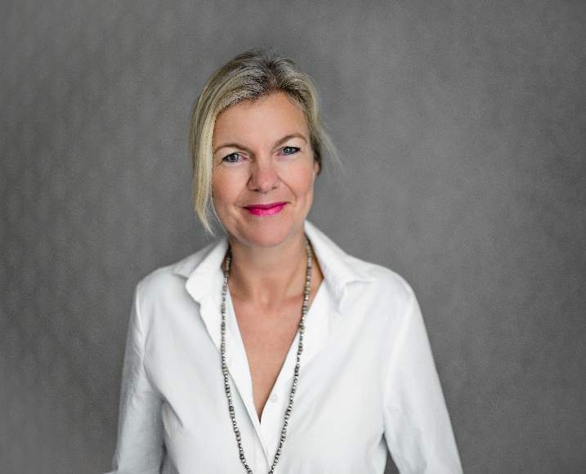
“Getting involved in a mediation process allows us to look at familiar thought patterns in different ways and helps us to accept other perspectives without judging them.”

Overview
Birgit is an experienced and highly competent conflict management trainer, facilitator and mediator with strong communication skills and a high level of empathy allowing her corporate clients to feel more comfortable and less stressed during the entire mediation process. She always keeps the settlement goal in view, while helping the parties to focus on their interests, needs, priorities and options.
While working as a European Project Manager, developer and intercultural trainer for over 15 years Birgit has become eminently experienced in intercultural problem solving. During that time she also became an Accredited Mediator in 2011, was admitted to the largest Mediation Association in Germany BM® in 2013 and joined as an Accredited Mediator the Centre of Effective Dispute Resolution (CEDR) in 2015 to gain insight into the Anglo-Saxon dispute resolution approach.
Since 2013 Birgit has been facilitating the mock sessions conducted in English for Bucerius Law School students in preparation for the ICC Commercial Mediation Competition taking place each year in Paris.
As member of the Board of the Hamburg Institute of Mediation (HIM) since 2013, she has expanded and upgraded a special training programme for experienced mediators since 2015, and was elected as Vice-President in 2020.
In her role as consultant, mediator, trainer and speaker she has worked with clients in almost all EU countries as well as Switzerland and especially in the Ukraine, with NGOs, government organisations and corporate clients.

Turning Point in her Life as Mediator

A pivotal moment in her life as mediator were Birgit's two weeks working for an international NGO in the Ukraine’s Donbas region close to the line of fighting in 2016. There Birgit trained supervisors and psychologists of traumatized citizens and veterans in how to cope with severely escalated conflict situations.
Her activities performed during her stay:
- Finding solutions for highly escalated conflicts by stimulating roleplays
- Implementing feasible tools and unconventional methods into the dispute resolution process
Personal Style

Birgit has an encouraging approach towards the case. As a facilitator, she untangles emotional ties to establish common ground between the parties. Her clients especially like her high level of sensitiveness and proactive guidance.

Expertise
Teambuilding and installation of Conflict Managment Systems with experience in the following industries:
- Retail (over 50 000 employees worldwide)
- Health & Pharmaceutical (over 100 000 employees worldwide)
- Public bodies (fire brigade, kindergarden)
- Mediator at Airbus multinational aerospace cooperation (12 000 employees in Hamburg, Germany)
Employment & Workplace
- Analysis and interviews in a major dispute opposing employees and management of a large retailer (3500 employees in Germany, over 50 000 worldwide)
- Coaching and profiling of an in-house mediator in a large retail company (over 3000 employees)
- Intra-organisational assessment for profit and non-profit organisations

Sale of Goods & Services
- Complaints procedures regarding professionalism and behaviour of service provider (SME)
- Complaints procedures regarding leadership personalities and staff (SME)

Health and Pharmaceuticals
- Developing and implementing diligent strategies for teambuilding and dispute resolution in a large pharmaceutical company (over 4000 employees in subsidiary, over 100 000 worldwide), ongoing process since 2019

Intercultural conflict resolution
- Intercultural consultant and speaker at private gynaecological hospital in Hamburg (over 50 employees)
- Intercultural conflicts between refugees working or taking training in national authorities
Public utility Company
- Long lasting dispute within the leadership of a fire brigade (over 200 employees)

Professional background
Born in Hamburg, Germany, Birgit has lived, studied and worked in Germany, France and the United States. She is fluent in all three languages and can mediate in both German and English.
From 2000 - 2015 she has been working in the field of transnational cooperation funded by the European Commission and has been involved as a project manager or coordinator, taking responsibility for the development and dissemination of long-term projects. She was one of the creators of the International Learning Platform “Altsolem”, which she later restructured, adjusted and implemented on the website of Arbeit und Leben Hamburg (AuL), a leading further education provider. Since 2004 Birgit has also been a lecturer for French and International Relations at the Hamburg School of Business Administration (HSBA). She holds the licence as a TELC (The European Language Certificate) examiner for French.
Birgit graduated with a Master of Arts degree in French and German Language and Literature from the University of Hamburg in 1987, having spent a one year exchange at the Université Paul Valéry of Montpellier as part of her studies. After working for a couple of years as a director of studies at ”Sight and Sound Hamburg” she took an Academic Year in comparative literature at Smith’s College in Northampton, Massachusetts, USA.

Professional Experience
- 2020 Vice-President of the Hamburg Institute of Mediation (HIM)
- 2015 Accredited Mediator at Centre of Effective Dispute Resolution (CEDR)
- 2014 Mediation Coach for law students at Bucerius Law School (BLS)
- 2013 Member of Board at Hamburg Institute of Mediation (HIM)
- 2011 Accredited Mediator at Hamburg Institute for constructive conflict solving (IKM)
- 2000-2015 European Project Manager, developer and coordinator (AuL Hamburg)

Studies & qualifications
- 1994/1995 Academic Year in Comparative Literature at Smith College, USA
- 1987 Master of Arts degree in French and German Literature at University of Hamburg, Germany
- 1983 - 1984 Année universitaire, Diplôme d’Études Générales at University Paul Valéry
Montpellier, France

